~ things happening at City Hall ~
Parking Ordinance
Now that we are changing seasons, it would be a great time to review the parking ordinance. Below are the guidelines taken from ordinance #157 pertaining to parking:
- General Parking Prohibition. No motor vehicle shall be parked on any public street for more than 48 continuous hours.
- Winter Parking Restriction. During the period of November 1st through May 1st, no motor vehicle shall be parked on any City Street during and/or after a snowfall, sleet or freezing rain where there has been any accumulation of snow, ice and similar debris until the street is cleared to its full width.
- Downtown Parking. No parking year-round from the hours of 2 a.m. – 6 a.m. in the following areas: 1) Broadway from 4th Ave to 1st Ave; 2) 2nd Street from 4th Ave to 1st Ave; 3) 3rd Ave from Hwy 58 to the alley adjacent White Rock Bank; 4) 2nd Ave from Broadway to the alley adjacent to the Corner Bar.
- Impoundment and Citation. Goodhue County Sheriff Department is hereby authorized to issue a citation in connection with any motor vehicle parked in violation of the ordinance. If the vehicle is unoccupied, it may be towed to a place of storage for safekeeping or impoundment. The Goodhue County Sheriff Department is hereby authorized and empowered to request any private garage or towing service to tow the vehicle.
- Prohibition on Snow Removal from Private Property. In addition to the above restrictions no person shall remove snow from private property and deposit the same on any public street or parking lot. Any snow deposited may be removed by the city and the cost of such removal shall be charged to the person in violation of this ordinance.
- Penalties. Any person who violates the provision shall be guilty of a petty misdemeanor, and the costs of prosecution may be added. These offenses shall be cumulated daily during the snow season of November 1st of each year through May 1st of the successive year. A separate offense shall be deemed committed upon each day of which the violation occurs or continues.
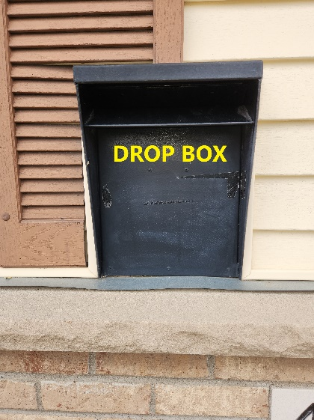
Payment/Document Drop-off Box at City Hall
At any time, you can drop off your utility bill payments in the labeled, black drop box that is located to the left of the glass City Hall entry door. It works just like a bank after-hours deposit slot – locked and secured box inside of the building. You can also drop off papers up to ½” thick and 10” wide for a city hall employee.

Garbage, Recycling & Burn Pile Questions
The items below are usually allowed in curbside toters, bins, cans or containers for standard trash collection:
- Diapers  - Disposable razors  - Cactus and palm branches  - Cat litter and pet feces  - Glassware and ceramic dishes/cups | - Hoses and wire  - Juice boxes/pouches  - Non-fluorescent light bulbs  - Foam cups or packing materials

The following hazardous household waste items should NOT be treated as everyday garbage and should NOT be disposed of curbside, in your totes, bins or carts:
- Batteries  - Electronics  - Fluorescent light bulbs | - Paint and paint cans  - Used motor oil and filters  - Prescription medications

- Wheel your carts to the street and place them curbside by 6 a.m. on your collection day. Do not overload carts; the lids must close completely. Overage fees may apply to overfilled carts. Make sure that all trash and debris are in the cart. Garbage or waste left beside carts may not be collected.
- The City of Goodhue is charged by the ton each month on our bill for garbage. Please recycle as much as you can to reduce our bill, which can reduce our garbage rates. We do have the additional benefit of having our own bulk recycling option in town if your own recycle bin is full. Larger recycled items can be brought to the South Broadway location, past the car wash and across from Seed Plus. Only recyclable items are accepted here too. There have been several neighboring cities who have lost their bulk recycling containers due to unallowable items being put into them. Please break down large boxes so more will fit.
- If there is a holiday during the week, garbage will be generally delayed by a day and then collected.
- A great resource is available on the Waste Management website: https://www.wm.com/us/en/recycle-right/recycling-101
- Our brush pile is for just that. Yard waste – branches, leaves, logs and any wood without nails, screws, etc. What is NOT allowed is building materials of any type, finished wood products, treated lumber, shingles, plastic, metal or garbage.

Did you know??
Our website has the capability of translating the contents to several different languages. Scroll all the way down on the home page on the left and choose your language and then select Translate button.
Empowering you with information that matters

